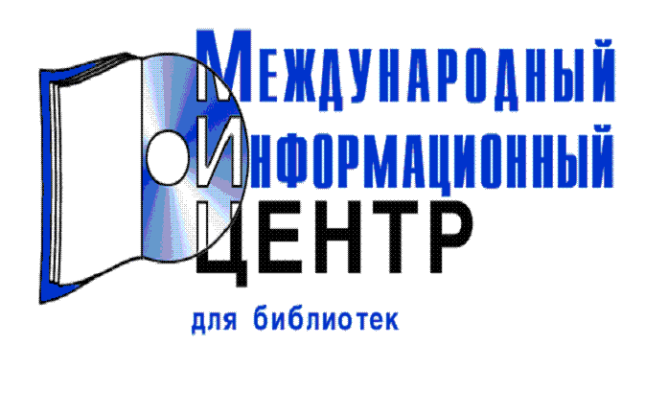
JBC Papers in Press
Journal de Pharmacie et de Chimie
Journal de Pharmacie et de Sciences Accessoires
Journal für Praktische Chemie (1870-1933)
Journal of Analytical Atomic Spectrometry (1997-, älter als 3 Jahre)
Journal of Antibiotics, The (1968-1994)
Journal of Automated Methods & Management in Chemistry
Journal of Biochemistry and Molecular Biology
Journal of Business Chemistry
Journal of Chemical Engineering of Japan (JCEJ) (-1988)
Journal of Chemical Engineering of Japan (JCEJ) (1992-)
Journal of Chemical Software, The
Journal of Computer Aided Chemistry (JCAC)
Journal of Computer Chemistry
Journal of Electrophoresis
Journal of Industrial and Engineering Chemistry
Journal of Lipid Research (älter als 12 Monate)
Journal of Managed Care Pharmacy (JMCP)
Journal of Materials Chemistry (1997-, älter als 3 Jahre)
Journal of Natural Gas Chemistry
Journal of Nuclear and Radiochemical Sciences (JNRS)
Journal of Pharmacy & Pharmaceutical Sciences
Journal of Photopolymer Science and Technology
Journal of Physical and Chemical Reference Data (JPCRD) (ältere Jahrgänge)
Journal of Physical Chemistry, The (Ältere Jahrgänge)
Journal of Rare Earths
Journal of the Argentine Chemical Society, The
Journal of the Brazilian Chemical Society
Journal of the Chemical Society, Faraday Transactions (1997-1998)
Journal of the Chilean Chemical Society
Journal of the Chinese Chemical Society
Journal of the Iranian Chemical Society (JICS)
Journal of the Korean Chemical Society (JKCS)
Journal of the Mass Spectrometry Society of Japan
Journal of the Mexican Chemical Society / Revista de la Sociedad Química de México
Journal of the Serbian Chemical Society
Journal, The: The New York State Journal of Health System Pharmacy, (formerly: The Pharmacist,)
Kemija u Industriji
KONA Powder and Particle
Korean Journal of Chemical Engineering
Korean Journal of Medicinal Chemistry, The (1991 - 1997)
Labor-Praxis

