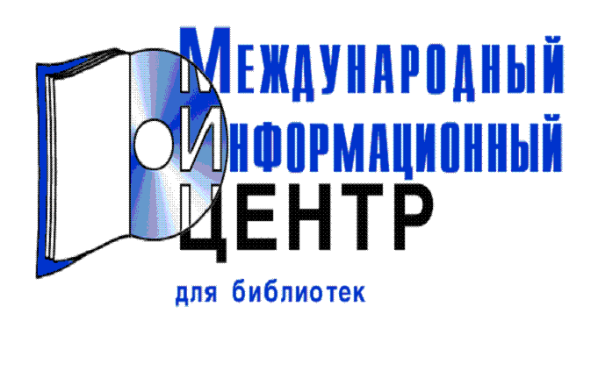
TA-SWISS Newsletter / Newsletter de TA-SWISS
TAB-Brief
Techmax
Technik in Bayern
Technikfolgenabschätzung - Theorie und Praxis (früher: TA-Datenbank-Nachrichten)
Techniques & Culture
Technology Interface
Technology Today
Technoscience
Tecnia : Revista Técnico Científica
Teknik @ Kultur: Nyt om Håndværk- og Industrihistorie
Teknisk Ukeblad
Thammasat International Journal of Science and Technology TIJSAT
TMAT: Theaeteto Atheniensi Mathematica
Transactions of the Japan Society for Computational Engineering and Science
Transactions of the Japan Welding Society
Trilateral Statistical Report
Tsinghua Science and Technology
Turkish Journal of Engineering and Environmental Sciences
VTT Horizons

